multi-Risk sciEnce for resilienT commUnities undeR a changiNg climate
Codice progetto MUR: PE00000005 C93C22005160002



Deliverable title: Hazard modelling of droughts by using historical data, seasonal forecasts and future climate scenarios.
Deliverable ID: 1.3.4
Due date: 1.06.2024
Submission date: 1.06.2024

AUTHORS
Jost von Hardenberg, Alberto Viglione, and Stefania Tamea (POLITO); Stefania Da Pelo, Giulio Vignoli, Antonio Coppola (UNICA) Matteo Camporese, Pietro Teatini (UNIPD); Luigi Piemontese (UNIFI), Maria Cristina Rulli (POLIMI), Giacomo Bertoldi (Eurac Research), Simone Gabellani, Roberto Rudari (Cima Foundation)

Technical references
Project Acronym | RETURN
Project Title | multi-Risk sciEnce for resilienT commUnities undeR a changiNg climate
Project Coordinator | Domenico Calcaterra  UNIVERSITA DEGLI STUDI DI NAPOLI FEDERICO II  domcalca@unina.it
Project Duration | December 2022 – November 2025 (36 months)

Deliverable No. | DV1.3.4
Dissemination level*
Work Package | WP1.3 - Drought risk under environmental and climatic changes
Task | T3.2 - Drought hazard modelling
Lead beneficiary | Cima Foundation
Contributing beneficiary/ies | UNIPD, POLITO, UNIFI, EURAC, CIMA, POLIMI.
* PU = Public
PP = Restricted to other programme participants (including the Commission Services)
RE = Restricted to a group specified by the consortium (including the Commission Services)
CO = Confidential, only for members of the consortium (including the Commission Services)

Document history
Version | Date | Lead contributor | Description
0.1 | 24.05.2024 | Pietro Teatini  UNIPD | First draft
0.2 | 27.05.2024 | Jost Von Hardenberg  (POLITO) | Critical review and proofreading
0.3 | 30.05.2024 | Roberto Rudari  (CIMA) | Edits for approval
1.0 | 31.05.2025 | Francesco Ballio | Final version

ABSTRACT
This report summarizes the contributions to the Deliverable DV 1.3.4, in which existing climate model and impact models developed in DV 1.3.3 are used to evaluate drought hazard, also through the generation and analysis of seasonal forecasts and climate scenarios. The contributions cover aspects of drought hazard quantification as follows:
A3.4.1 addresses the critical issue of saltwater contamination in the coastal aquifer system between the Venice lagoon and the Adige river. Field investigations and analyses have been carried out in a representative 11-hectare farmland near the Adriatic coastline, focusing on the relationship between groundwater quality and climatic conditions. The installation of an experimental setup is introduced to assess ways to mitigate saltwater intrusion at local scale.
A3.4.2 addresses the use of hydrological models, such as the Continuum model, to the seasonal and long-term quantification of drought hazards in the Po and Arno river basins. By integrating seasonal forecasts from the C3S suite and downscaling them using statistical approaches, these models aim to predict the Low Flow Index (LFI) and detect hydrological drought periods. This methodological framework facilitates a deeper understanding of the temporal evolution of drought conditions and their potential impacts on water resources.
A3.4.3 focuses on coupled soil-water balance and crop growth models to assess agricultural drought risks and forecast irrigation requirements. By incorporating meteorological, soil, and crop data, these models estimate evapotranspiration, soil moisture, and water deficits on a daily basis, offering critical insights into water stress in vegetation and the irrigation needs of crops. High-resolution datasets, such as ERA5 and VHR-REA_IT, enhance the accuracy of these models, providing a robust tool for agricultural water management under climate change.
A3.4.4 aims at quantifying how agricultural droughts propagate into broader water scarcity issues affecting multiple socio-economic sectors. By integrating data on water demands, irrigation networks, and socio-economic factors, these studies explore the complex interactions between meteorological, hydrological, and agricultural droughts. This comprehensive approach aims to inform policy and management strategies for mitigating the socio-economic consequences of drought in the Italian agricultural sector.
A3.4.5 focuses on the Adige watershed, where the research examines the impacts of snow droughts and summer flash droughts on hydropower production and agricultural productivity. By relating hydrological variables with drought impacts, this study enhances our understanding of drought formation and its implications for water resource management in mountainous regions. The integration of remote sensing data and detailed crop statistics provides a view of drought-induced stress on key sectors in the Alpine landscape.
A3.4.6 investigates the probability and mechanisms of prolonged droughts in the Mediterranean and Greater Alpine regions, through large ensembles of climate model simulations. By analyzing both the Coupled Model Intercomparison Project Sixth Phase (CMIP6) and multi-model large ensembles (MMLEs), researchers aim to separate the forced climate response from internal atmospheric variability. This probabilistic approach offers valuable insights into the predictability and future trends of droughts, enhancing our ability to anticipate and mitigate the impacts of climate change on regional hydrology.

3. Table of contents
Technical references 2
Document history 3
ABSTRACT 4
3. Table of contents 5
4. Contributions 6
4.1 Modelling the effects of future climate scenarios on saltwater in phreatic coastal aquifers OR effects of future climate scenarios and land use change on recharge patterns in the Venetian high plain and Po delta 6
4.2 Use of hydrological models for the seasonal, long-term quantification of drought hazards under climate change forcing. 7
4.3 Seasonal forecast of irrigation requirement and agricultural drought modelling in Northern Italy 8
4.3.1 Method 8
1.1.1. 4.3.2 Data 8
1.1.2. 4.3.2 Current state and ongoing work 9
4.4 Seasonal forecast of irrigation requirement and agricultural drought modelling in Northern Italy 10
4.5 Test of the models developed in Task A 3.3.8 in specific catchments of the Alpine region (i.e. Adige watershed) for seasonal drought forecast (snow droughts; summer flash droughts 11
4.6 Estimating the probability and the large-scale mechanisms for prolonged droughts under climate change on the Mediterranean and Greater Alpine regions in large ensembles of climate model simulations 12
1.1.3. 4.6.1 Metodology 13
1.1.4. 4.6.2 Characterization of historical and future droughts 13
5. Conclusions 15
7. References 16

List of Figures
Figure 1: model output for Maize in Verolengo, Piemonte 20224 9
Figure 2 Preliminary assessment of the number of months experiencing water scarcity in Italy 11
Figure 3 Future change for the Mediterranean region, as percentage of dry months over a period of 30 years (defined as months having SPI6<-1). The figure represents a multimodel mean over CMIP6 models in the SSP5-85 scenario 14

4. Contributions

4.1 Modelling the effects of future climate scenarios on saltwater in phreatic coastal aquifers OR effects of future climate scenarios and land use change on recharge patterns in the Venetian high plain and Po delta
Research activities have been carried out in the coastal aquifer system comprised between the Venice lagoon and the Adige river mouth where saltwater contamination is a main process threatening the environment and the agricultural productions. Field investigations and analyses are ongoing since a few years ago in a farmland a few km inland from the Adriatic coastline. The experimental site covers an 11-ha field cultivated with rainfed maize, lying 2 to 3 m below the msl, and characterized by silty clay soil rich in organic matter intersected by sandy paleo-river beds. This site can be considered as a representative example of the entire coastland of the Po plain stretching from Monfalcone in the north to Rimini in the south. The investigations encompass various parameters, including weather conditions (rainfall, solar radiation, temperature, relative humidity, wind), surface water levels and electrical conductivity, depths to the water table, soil moisture, groundwater quality (electrical conductivity, pH, main ions). Additionally, hydro-geophysical characterization and monitoring have been implemented, alongside soil characterization (texture, pH, and cation exchange capacity).
Monitoring activities, which are ongoing in the area since 2019, has allow to capture the evolution of saltwater concentration in the phreatic aquifer and the surrounding water bodies and to evaluate their relationship with the climatic conditions. Monitoring have been carried out after and before the establishment of an experimental infrastructure to perform aquifer recharge with freshwater. The infrastructure consists of an intake from an reclamation channel, through a vertical pipe with two openings located at different heights and a control valve for each opening. It supplied freshwater by gravity into a 200 m-long buried pipe drain with a diameter of 0.16 m. The corrugated polyethylene drainpipe was installed at 1.5 m depth along the 10 to 15 m-wide eastern paleochannel by digging a 0.5 m-wide trench. A maximum 2.5 m head difference between the water level in the reclamation channel and the water table in the surrounding farmland guaranteed a maximum discharge rate of approx 30 l s-1. The actual water flux was controlled by two valves.
Possible relationships between groundwater, soil water, seawater intrusion, and boundary conditions were investigated with three methods:
• Univariate simple statistics. Groundwater variables were tested with non-parametric methods since data showed a non-normal distribution. Univariate simple statistics were applied to each sampled chemical parameter and groundwater electrical conductivity (ECw) was plotted against the most abundant ions in seawater (i.e., Cl-, Na+, and SO42-) using Spearman’s rank correlation coefficients.
• Principal component analysis (PCA). The PCA technique was applied to investigate possible relationships between weather conditions, river water quality, groundwater, and soil water data. Three PCAs were performed: 2019-2020 (i.e., the period before the freshwater recharge), 2021, and 2022. The investigated variables are: rain, ECw as measured in various 2-m deep boreholes established in the study area, drain flow rate, EC of the recharge water, soil water content, major groundwater ions (Cl−, Br−, SO42−, Na+, K+, Mg2+, Ca2+), Cl/Br ratio, and depth to the water table. The significance of the eigenvalues was demonstrated by the Bartlett Test.
• Cl/Br molar ratios calculation. Cl− and Br− are conservative tracers and their ratio remains constant even if their concentrations change due to physical processes. This ratio is effective in the identification of groundwater salinity origin.
The monitoring campaigns and the statistical analyses confirmed that the experimental site is strongly affected by salt contamination. The monitoring sites located in the sandy paleochannel were characterized by a slightly brackish top 1 m of groundwater. Despite this, the Cl/Br molar ratio highlights that salinity in the site closer to the lagoon originated from seawater. On the contrary, the salinity of the other two sites is mainly soil-driven. The PCA confirms these results highlighting that the variability of the sites closer to the lagoon is explained by the component related to seawater intrusion and groundwater salinity, while for the others the variability is explained by mineral soil-driven water quality (Ca2+, SO42-, and soil water content, pore electrical conductivity, effective evapotranspiration, and rainfall. Outside the paleochannel, sites with almost fresh and sites with saline waters were detected. In the sites with the presence of outcropping peaty layers, i.e. with very high soil organic carbon and cation exchange capacity, the salinity may be caused by the percolation of the high quantity of salts retained by the peat layer. This is confirmed by Cl/Br value higher than the seawater one which means that there was an additional source of Cl-.
The most evident effect of the freshwater recharge was observed in groundwater. It is worth noting that the injected water was characterized by a largely variable electrical conductivity. During the 2022 drought season, the value of the water used for the recharge averaged 2 mS cm-1, i.e. differing not significantly from the shallow groundwater ECw in this site. Time-lapsed ERT surveys confirmed to be a non-invasive and cost-effective geophysical technique able to capture saline water intrusion spatial variability due to the peculiar sensitivity to the electrical conductivity of pore fluids which typically results in a strong contrast between fresh- and saltwater. The acquisitions showed an enlargement of a more resistive volume around the drainpipe during the injection phase associated with the freshwater flow in the subsurface, while there is a general worsening (resistivity decrease) of the soil condition far from the drainpipe A comparison between the well location and the lateral extent of the paleochannel, allows to conclude that the positive effect of the freshwater recharge involved the whole paleochannel but did not laterally extend further. Consequently, the adopted strategy helps reducing salt contamination at a local scale only.
Moreover, a field campaign is initiated to detect shallow and deep boreholes in the Po river delta which could result suitable to monitor salt concentration at depth. The goal is to establish a first monitoring network for the saltwater concentration in the aquifer system of the area. In fact, in the Po river delta saltwater concentration has been monitored in the surficial waterbodies and in the very shallow soil (the depth range of interest for the agricultural practices) only, but no information is available for larger depths spanning the Holocene and the Pleistocene. The need to characterize water quality in this depth range, i.e. approximately from 1-2 m below the land surface to 50-100 m below the msl, would require the use of previous boreholes as the project funds cannot cover borehole drilling. A number of 15 CTD sensors equipped with automatic logger has been recently ordered and will be placed in the detected boreholes.

4.2 Use of hydrological models for the seasonal, long-term quantification of drought hazards under climate change forcing.
The Continuum model implemented on the Po basin within the activity A3.3.3 (Hydrological models for the quantification of hydrological drought hazards at seasonal and climatological scale in the Po watershed and Arno watershed) is used, coupled with seasonal forecast, to forecast, at seasonal scale, the evolution of the LFI- Low Flow Index.
In this phase the methodological framework has been developed: seasonal forecasts will be from the C3S suite (https://cds.climate.copernicus.eu/about-c3s) and will be downscaled across the Po River basin using statistical approaches based on topography and precipitation structure. Meanwhile, Continuum is being run over an historical period and possibly fine-tuned to better reproduce streamflow patterns at seasonal time scale. Afterwards, a hindcast experiment will be performed using a database of historical seasonal forecasts, with the specific aim of testing the potential of seasonal forecasting to detect periods of hydrologic droughts – as defined by the LFI.

4.3 Seasonal forecast of irrigation requirement and agricultural drought modelling in Northern Italy
The development of coupled models of soil-water-balance and crop modelling has enabled the quantification of both water stress in (rainfed) vegetation and of irrigation requirements in irrigated agriculture. One of such models is being developed here to advance the knowledge of agricultural droughts by offering the possibility to assess the drought risk and to anticipate adverse impacts of meteorological drought. The approach requires the integration of robust and verified modelling routines stemming from previous works (e.g., Tuninetti et al. 2015, Rolle et al. 2021), the integration with satellite data to improve the knowledge of soil moisture and vegetation, and a fine description of agricultural land use and cultivations in the Po valley.

4.3.1 Method
Monitoring water status in plants and determining irrigation requirements necessitate information about soil water dynamics which is addressed by soil-water balance accounting for soil water input (i.e., precipitation, irrigation), output (i.e., evapotranspiration), and storage (i.e., soil moisture). A Python-based model has been developed which incorporates meteorological, soil, and crop data to estimate reference evapotranspiration ($ET_{0}$), crop actual evapotranspiration ($ET_{a}$), soil moisture (SM), total and readily available water contents (TAW, RAW), water deficit and surplus on a daily basis within the crop growing season.
Applied to land equipped for irrigation, the model returns the irrigation requirement based on a reference evapotranspiration (ET0) obtained through Hargreaves-Samani method (Hargreaves and Samani, 1985) and an actual evapotranspiration defined according to FAO (Allen et al. 1998), i.e.
$ET_{a}=ET_{0}∙k_{c}∙k_{s}$ ;
where $ET_{0}$ and $ET_{a}$ are expressed in mm/day, $k_{c}$ is a dimensionless coefficient specific for each crop and growing phase (or crop coefficient), and $k_{s}$ is the water stress coefficient that takes values from 0 to 1. When $k_{s}=1$, the evapotranspiration is not affected by water stress and reaches the maximum rate. If $k_{s}=0$, the crop reaches the wilting point because of the dry soil condition, and there is no evapotranspiration.
The $k_{s}$ coefficient depends on the soil water content in the soil, which depends on the inflows and outflows, among which are precipitation, irrigation if provided, evapotranspiration, surface runoff, seepage and capillary fluxes. $k_{s}$ therefore depends also on the hydraulic parameters of soil which govern the motion of water in saturated and unsaturated conditions, as well as on the evapotranspiration flux expressed above. The input data are identified as follows.

4.3.2 Data
Meteorological data
ERA5 reanalysis (Hersbach et at, 2020), developed by the European Centre for Medium-Range Weather Forecasts (ECMWF), is the most widely used georeferenced global dataset on hourly climate variables in research studies, having been cited over 14000 times. ERA5 reanalysis has a spatial resolution of 0.28 ° (~31 km), and its derivative products, such as ERA5-Land, and a regional reanalysis for European domain, offer finer resolutions of 9 km and 5 km, respectively. For agricultural management issues, such as crop water stress and irrigation requirements, higher-resolution data can be a game changer as they provide more details and enhance the reliability of results. In this regard, Centro Euro-Mediterraneo sui Cambiamenti Climatici (CMCC) recently published VHR-REA_IT (Very High-Resolution REAnalysis for Italy), a downscaled ERA5 dataset over Italy with spatial resolution of 2.2 km (Raffa et al., 2021), which is used for meteorological input (i.e., precipitation and temperature) of the model.
Soil data
Soil properties play a pivotal role in elucidating soil moisture dynamics and irrigation requirements, offering deeper insights into the intricate processes from infiltration to deep percolation. In the initial modeling endeavor, however, available water capacity (AWC) is the only essential soil property required denoting the volume of water stored in soil profile, between field capacity (theta) and wilting point (w), accessible to plants. The latest version of the Harmonized World Soil Database (HWSD) published recently by FAO and IIASA (2023) provides rich georeferenced information on soil (i.e., AWC) globally at spatial resolution of 1 km and is used as reference soil properties source of the model.
Crop data
The model is crop-sensitive and thus along with croplands mask, requires information on crop phenology, including the duration of the growing season, crop coefficient (Kc), and rooting depth. CROPGRIDS, a recently published globally georeferenced crop area dataset for 173 crops for the year 2020 building upon MRF dataset for the year of 2000 (Monfreda et al, 2008), integrates all recent data (from 2000 to 2020) either published or collected on subnational scale at spatial resolution of 0.05° (~ 5.6 km), is used as the primary reference croplands mask. This for Europe, however, is to be compared and validated with EUROCROPMAP 2022 (d’Andrimont et al, 2021) published by the EU Joint Research Centre (JRC), and for Northern Italy (i.e., Po basin) in particular, with data currently being collected from local authorities and institutions. As for crop phenology, the Global Gridded Crop Model Intercomparison (GGCMI)- phase 3 crop calendar, covering 18 major crops, is utilized (Jägermeyr et al, 2021). Should crops not included in the GGCMI be considered, either agronomically similar crops or information from relevant literature sources will be employed.

4.3.2 Current state and ongoing work
To elaborate further on the functionality of the model, an example of the model's output is provided in Figure 1. The model is being tested versus a previous set of results obtained at a coarser spatial grid at the global scale, as detailed in Rolle et al. (2021). In the meanwhile, the collection, analyses and verification of seasonal forecasts of meteorological variables are being developed within the project activity n. A 3.2.1 (in WP3.1 “Predictive skill of drought-specific indexes of existing C3S seasonal forecast systems”).
Data from the ECMWF’s fifth generation seasonal forecast system (SEAS5) and from other seasonal forecast systems are obtained from the Copernicus Climate Data Store (CDS, https://climate.copernicus.eu/). Data contribute to a multi-model ensemble having a 1 degree spatial resolution and daily frequency, with relevant variables being the precipitation and mean, min and max temperature. These data will be used to input the model described above to generate ensemble forecasts of irrigation requirements. Results will be investigated in their capability to predict irrigation requirements with different lead times and with reference to different periods of the crop growing season.

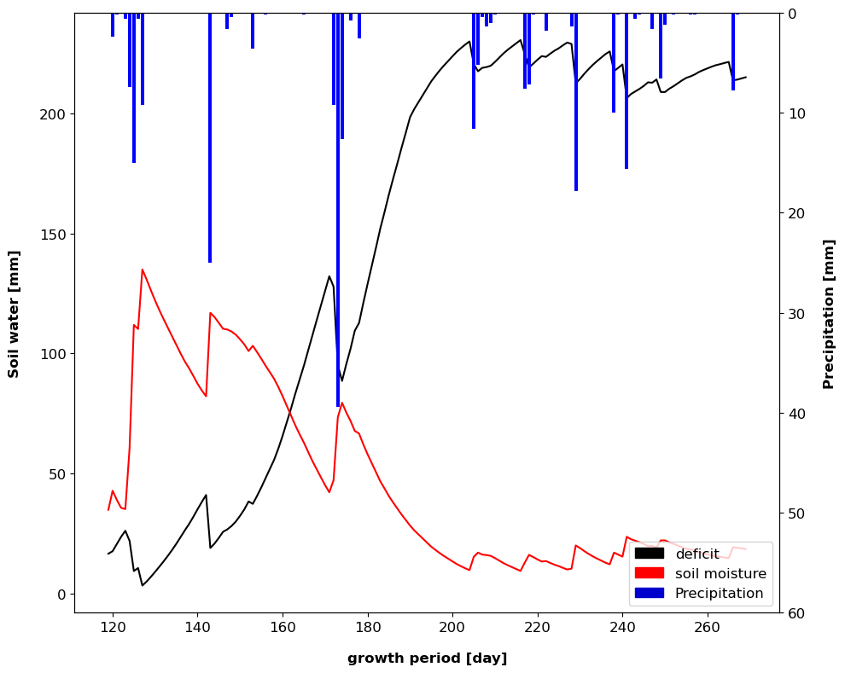
Figure 1: model output for Maize in Verolengo, Piemonte 2022

4.4 Seasonal forecast of irrigation requirement and agricultural drought modelling in Northern Italy
The aim of this activity is to integrate the modeling structure, developed in A3.3.5 and presented in the deliverable DV1.3.3, with data and analyses on other water users and with modeling inputs from global change scenarios. The goal is to enable further investigations on the propagation of agricultural drought into socio-economic drought and on the response of the Italian agricultural sector to global change scenarios.
Due to the process-based, biophysical nature of the selected agricultural drought hazard modeling strategy, we rely on water scarcity metrics that can accommodate such outputs and provide proxies of socio-economic drought. Blue water scarcity, in particular, is defined as the ratio between water demand from multiple socio-economic sectors and water availability, net of upstream withdrawals and of environmental flow requirements. Blue water scarcity can be impacted by agricultural drought both directly, through increased demands for irrigation, and indirectly, due to reduced formation of runoff within agricultural areas, which would otherwise contribute to freshwater supply. Similarly to A3.3.5, A3.4.4 aims at leveraging local data availability to refine modeling outputs and serve as a basis for further investigation. Thus, irrigation water demands can be directly taken from WATNEEDS outputs, either in form of biophysical demands or considering different irrigation water management strategies and different irrigation systems, where this information is available. WATNEEDS provides blue water demands in a spatially distributed way, associating crop-specific water volumes (depending on crop demand and harvested area) to each 30s-resolution pixel. However, to compute the blue water scarcity, these flows must be considered both as water demands in the pixel where the demand arises and as potential reductions in water availabilities downstream of where the withdrawal might actually occur. This, in turn, depends on the structure of the irrigation channel network. Regional databases on irrigation channel networks are available for the Po plain. We therefore merged them and analyzed them to obtain spatial associations between water withdrawal points from rivers and irrigation delivery areas. This can lead to a refined analysis on how agricultural drought meteorological drought and hydrological drought can interact with agricultural drought (Figure 2).
The main challenge in this is the lack of information regarding effective irrigation water deliveries within irrigation consortia, which limits the possibility of validating model outputs. The best currently available information on this appears to be ISTAT data at the municipality scale. However, when discrepancies are found between models and ISTAT data, it is not straightforward to infer a “real” use of water, between what models estimate as biophysical water demand and what ISTAT provides as declared water use. To further move from agricultural drought to water scarcity, and thus to representations closer to socio-economic drought, water uses for other sectors are needed. ISTAT provides water supplied to local networks at municipal scale. This is a significant improvement in terms of accuracy with respect to global gridded databases on domestic and industrial water uses. Yet, while domestic uses could be disaggregated based on population density with reasonable approximation, the challenge of disaggregating municipal-scale industrial water uses remains open.

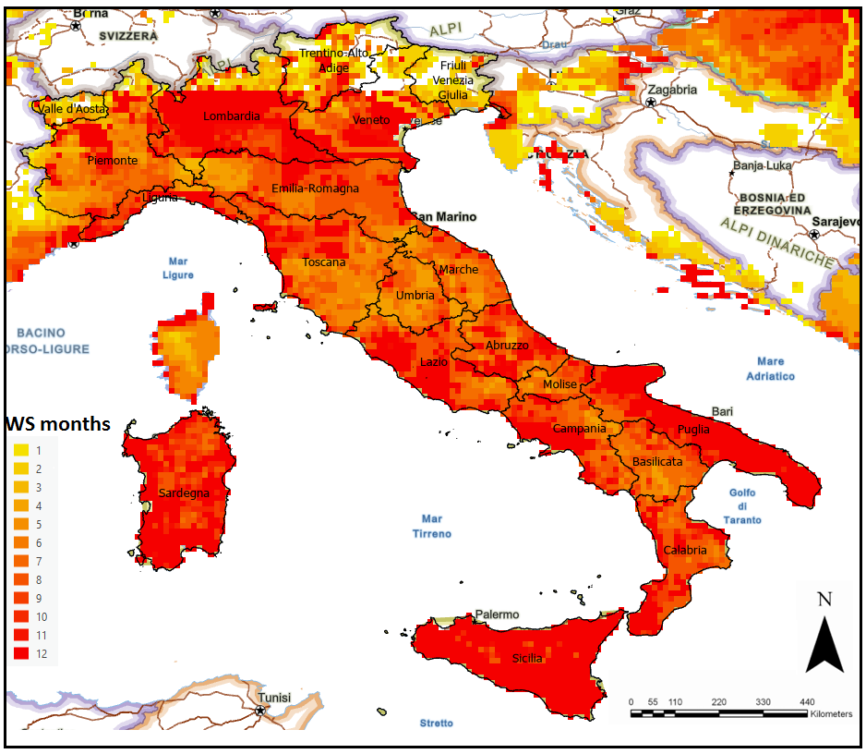
Figure 2 Preliminary assessment of the number of months experiencing water scarcity in Italy.

4.5 Test of the models developed in Task A 3.3.8 in specific catchments of the Alpine region (i.e. Adige watershed) for seasonal drought forecast (snow droughts; summer flash droughts
Following the contribution A3.3.8 presented in the deliverable DV 1.3.3, the current activity aims at presenting the second phase of the research work, dedicated to Impact Observations.
In the Adige catchment, hydropower production and agricultural productivity are the two sectors that are more prone to drought-related stress or impacts. Different impacts are triggered by drought occurring at different scales or concerning processes: variations in evaporation rates across different land cover types and elevations influence water availability and soil moisture dynamics. Changes in snowpack accumulation and melt patterns impact spring runoff timing and streamflow regimes, while fluctuations in soil moisture levels affect crop growth, water uptake, and agricultural productivity. Hence, correlating impact patterns with those of hydro-meteorological variables can improve our understanding of drought formation across the region's varied landscape. The correlation analysis will be carried out in the context of A3.1.2. The following sources of impact information are currently available:
• Hydropower Production: Monthly hydropower production data related to the provinces of Trento and Bolzano (provided by TERNA for 2000-2015 and then yearly for 2016-2022) provide insights into water availability and energy generation capacity during drought periods. Decreases in hydropower production can indicate reduced streamflow and water availability. Drought conditions can significantly influence hydropower production in the Adige catchment due to its diverse topography and hydrological characteristics. In mountainous areas, where snowmelt runoff contributes to streamflow, reductions in SWE and changes in snowmelt timing can affect water availability for hydropower generation. Conversely, in lower elevation areas with predominantly rain-fed streams, decreased precipitation and soil moisture deficits can lead to reduced streamflow and energy production capacity.
• Agricultural Productivity: Agricultural activities in the Adige catchment are primarily concentrated in plains and hills, relying on water resources originating from the entire catchment. Drought-induced soil moisture deficits and reduced streamflow can impact crop yields, especially for water-intensive crops such as fruit orchards and vineyards. Evapotranspiration rates play a critical role in regulating water use by crops, with high rates exacerbating water stress during dry periods. In this context, Harmonised sub-national crop statistics accessed through the data portal of the Italian institute for Statistics (ISTAT), track the yearly yield of several crop types, including apples and wine grape which are the most relevant cultivations in the Adige catchment. The main shortcoming of this source of data is its temporal granularity (yearly, thus harder to associate with specific drought events). These statistics are available for years 2006-2022 with reference to the provinces of Trento and Bolzano.
• Remote sensing-derived Evaporative Stress Index (ESI): these data will be derived in the context of A3.1.3 (VS1 – WP3 - Task 1). ESI is defined as the standardized anomaly of the relative evapotranspiration fraction, defined as the ratio of actual to potential ET (Anderson et al. 2011).
• European Drought Impact Database (EDID): the dataset includes drought impact records on various sectors retrieved from scientific sources, technical reports, and news articles. Impacts are categorized by sector (energy, agriculture, social, etc.) and a severity attribute (1 – least severe to 3 – most severe) is given to each event. EDID is, to our knowledge, the most organic repository of drought impacts available.
The joint analysis of impact observations and hydrological modeling outputs can improve the accuracy of drought monitoring and will help develop targeted modelling strategies to predict the more uncertain cascading drought hazards to be expected in the future. This latter part will be developed in A3.4.5 once the preliminary results from A3.3.8 and A3.1.2 are obtained.

4.6 Estimating the probability and the large-scale mechanisms for prolonged droughts under climate change on the Mediterranean and Greater Alpine regions in large ensembles of climate model simulations
Forecasting droughts in the mid-latitudes is a challenging task due to the stochastic nature of atmospheric internal variability and the inaccuracy of convective schemes in state-of-the art climate models. This unpredictable internal variability not only introduces inherent uncertainty into future climate projections but also complicates the interpretation of historical climate data. Our work aims at improving our understanding of the mechanisms driving historical and future drought events with a specific focus on the Mediterranean region, which has implications on drought predictability in the coming decades. To this end, we investigate Mediterranean droughts and their driving mechanisms in model experiments archived in Coupled Model Intercomparison Project Sixth Phase (CMIP6) and multi-model large ensembles (MMLEs).
The CMIP6 provides a large sample size including >30 different models that contributed to the historical (1850-2014) and future simulations (2015-2100). While inter-model agreement within the model diversity provided by the CMIP6 archive could give clear signals regarding future trends, a probabilistic approach and a full quantification of the role of internal atmospheric variability cannot be achieved with the limited number of ensemble members provided by each model in CMIP6. On the other hand, MMLEs provide a large number of ensemble members (ranging from 20 to 100) for each model, although there is a limited amount of available models (6 to 8). Advantages of MMLEs are manifold. First, they allow for more reliable and robust estimation of probabilities, trends, and extremes. Second, in MMLEs it is straightforward to separate the forced climate change (via the ensemble mean) from the internal variability (residual to the ensemble mean), also on regional scales (Kay et al. 2015). Last, LE can be used to assess externally induced changes in the characteristics of simulated internal variability, including extreme events, for which large sample sizes are crucial (Deser and Phillips 2023, Tebaldi et al. 2021). By averaging a large number of ensemble members across multiple models, it is possible to constrain the forced response due to anthropogenic forcing, while by examining the ensemble spread it is possible to fully account for atmospheric internal variability. The combination of the two archives thus leads to an overall better understanding of drought predictability amongst models, but also allows for a probabilistic approach using the large ensembles.

4.6.1 Metodology
To detect droughts, we employ the Standardized Precipitation Index (SPI, McKee et al. 1993) and the Standardized Precipitation Evapotranspiration Index (SPEI, Vicente-Serrano 2010) (the latter being more suitable for the Mediterranean region because accounts also for the effect of increasing temperature on the water balance). The SPI is a statistical indicator that quantifies the number of standard deviations by which an anomaly in precipitation deviates from its long-term mean at a specific location. Precipitation data are transformed to Gaussian (normal) equivalents, and then used to compute the dimensionless SPI value, defined as the standardized anomaly of the precipitation. The SPEI is analogous to the SPI, but is based on the water balance (precipitation minus potential evapotranspiration).
For a year k:
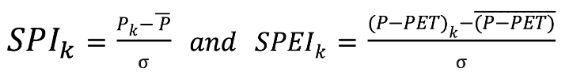

4.6.2 Characterization of historical and future droughts
We first examine historical runs and future simulations of the Mediterranean SPI and SPEI (in both CMIP6 models and MMLEs) to identify changes in droughts' duration, severity and frequency, and to detect long term trends. Through Empirical Orthogonal Function (EOF) analysis we explore how droughts patterns vary spatially across the Mediterranean basin and identify areas experiencing more severe or frequent droughts than the others.
Secondly, we use both drought indices to identify drier than normal conditions (SPI or SPEI < -1) (see for example Fig. 3). Using this criterion, we extract the corresponding mean geopotential fields and generate composite maps. These maps show large-scale synoptic circulation patterns prevailing during drought periods. Further, we use machine learning tools and clustering techniques to identify weather regimes, such as blocking patterns and different North Atlantic Oscillation (NAO) phases, that are associated with long drought events in the Mediterranean region (Schaller et al. 2018). Since we find correlations with blocking events, we further investigate blocking using more specialized tools based on the reversal of the mean atmospheric westerly flow at the mid-latitudes (e.g., Davini et al. 2012). We analyze the frequency, duration, and intensity of several atmospheric blocking patterns to understand their link with drought occurrence and persistence. Despite the fact that a strong relationship between blocking and temperature extremes has been largely established in some models, there is no comprehensive assessment across models and in MMLEs. In addition, summer blocking over the North Atlantic-European region has been more difficult to investigate up to now because it occurs less often than winter blocking. Therefore, the link between summer droughts and blocking is difficult to assess from the observational record and single-model simulations only, but MMLEs can be useful to obtain a more robust understanding. With this analysis, we seek to improve predictability of Mediterranean droughts.
Finally, the large sample of atmospheric conditions obtained from MMLE can be used to identify very rare and potentially high-impact events that are plausible but have not yet occurred in the observational record (or have occurred sporadically). We combine this event-based analysis with storylines to improve our understanding of the physical drivers and life cycle of these very extreme events (Bevacqua et al. 2023). Overall, our work helps us estimate the probability of occurrence of droughts, also of the more extreme ones both in the historical and future climate change.

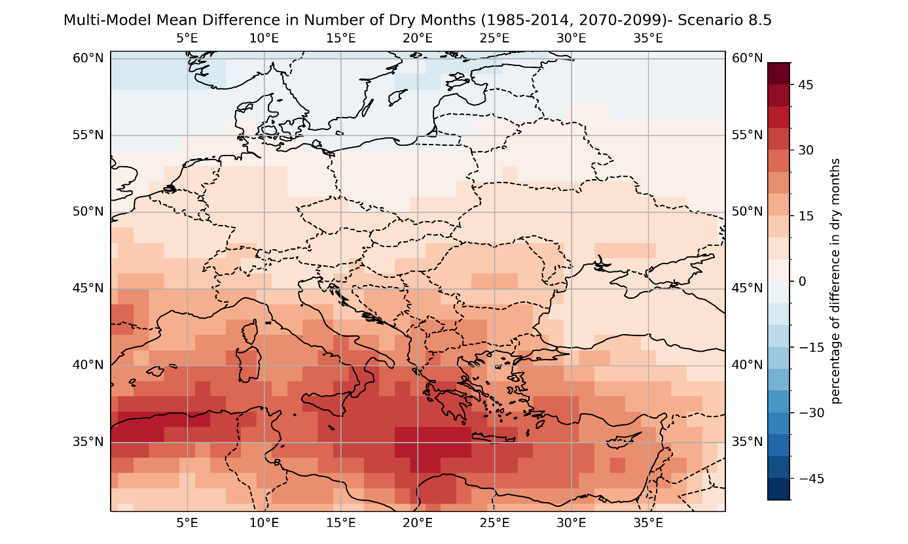
Figure 3. Future change for the Mediterranean region, as percentage of dry months over a period of 30 years (defined as months having SPI6<-1). The figure represents a multimodel mean over CMIP6 models in the SSP5-85 scenario.

5. Conclusions
The dynamics of hydrological systems are influenced by climate change in different ways, which require deep understanding for being projected to he future scenarios. This deliverable shows a number of ongoing activities that aim at quantifying drought hazard, especially through the use of seasonal forecasts and climate scenarios.
Contributions focus on multiple facets of hydrological and agricultural responses to climate variability, with a particular focus on the Mediterranean and Alpine regions, including the Po Basin and Venetian high plain. By leveraging advanced hydrological models, extensive field data, and innovative statistical techniques, these studies aim to enhance our understanding of drought hazards, saltwater intrusion, and agricultural water requirements under evolving climatic conditions. Each contribution offers a unique lens through which the impact of a changing climate, a changing environment and a changing anthropic use of water intertwine in a complex interaction. Here below are some specific conclusions drawn from the contributions above.

A.3.4.1) The coastal aquifer between the Venice lagoon and the Adige river faces significant saltwater contamination, threatening environmental and agricultural sustainability. Experimental interventions, such as aquifer recharge with freshwater, have been implemented and monitored since 2019. These interventions are designed to counteract saltwater intrusion by using freshwater from a reclamation channel. The results indicate that while the freshwater recharge strategy is locally effective in reducing salt contamination, its benefits do not extend beyond the immediate area of the paleochannel.
A.3.4.2) Future climate scenarios and land use changes are modeled to understand their effects on recharge patterns in the Venetian high plain and Po delta. The research uses field investigations, statistical analyses, and geophysical monitoring to study various parameters, including weather conditions, water levels, and groundwater quality. Principal Component Analysis (PCA) and other statistical methods have highlighted the different sources and mechanisms of salinity at various sites, distinguishing between seawater intrusion and soil-driven salinity.
A.3.4.3) Hydrological models, such as the Continuum model, are being used to forecast hydrological drought hazards on a seasonal scale in the Po watershed. Seasonal forecasts are downscaled using statistical approaches to predict the evolution of the Low Flow Index (LFI), which helps in assessing drought periods.
A.3.4.4) Advanced soil-water-balance and crop modeling techniques are being developed to quantify water stress in vegetation and irrigation requirements in Northern Italy. The integration of meteorological, soil, and crop data, along with high-resolution datasets, enhances the reliability of predictions related to agricultural drought and irrigation needs.
A.3.4.5) The modeling of agricultural drought extends to understanding its socio-economic impacts, particularly in terms of water scarcity affecting multiple sectors. Data on irrigation water demands and their spatial distribution, as well as the interaction between agricultural drought and water scarcity, are being analyzed to provide insights into socio-economic drought.
A.3.4.6) In the Adige catchment, the impacts of drought on hydropower production and agricultural productivity are being studied. Data from various sources, including hydropower production records, agricultural statistics, and remote sensing, are used to correlate drought impacts with hydrological variables.
A.3.4.7) Large-scale climate model simulations (CMIP6 and MMLEs) are used to improve the understanding of drought mechanisms and predict prolonged droughts in the Mediterranean and Greater Alpine regions. The use of standardized drought indices (SPI and SPEI) helps in characterizing historical and future droughts, accounting for both precipitation and temperature effects.

Overall, these research activities and modeling efforts contribute to a comprehensive understanding of the impacts of climate change and land use on water resources, salinity issues, agricultural drought, and socio-economic consequences in Northern Italy and the Mediterranean region.

7. References

Allen RG, Pereira LS, Raes D, Smith M. Crop evapotranspiration: Guidelines for computing crop water requirements. FAO Irrig. Drain P., 56. 1998.847-5
Bevacqua, E., Suarez-Gutierrez, L., Jézéquel, A. et al. Advancing research on compound weather and climate events via large ensemble model simulations. Nat Commun 14, 2145 (2023). https://doi.org/10.1038/s41467-023-37 Hargreaves, G.H., and Z. A. Samani, “Reference crop evapotranspiration from temperature,” Appl. Eng. Agric., vol. 1, no. 2, pp. 96–99, 1985.
d’Andrimont, r., A. Verhegghen, G. Lemoine, P. Kempeneers, M. Meroni, and M. van der Velde, “From parcel to continental scale – A first European crop type map based on Sentinel-1 and LUCAS Copernicus in-situ observations,” Remote Sens. Environ., vol. 266, p. 112708, Dec. 2021, doi: 10.1016/j.rse.2021.112708.
Davini, P., C. Cagnazzo, S. Gualdi, and A. Navarra, 2012: Bidimensional Diagnostics, Variability, and Trends of Northern Hemisphere Blocking. J. Climate, 25, 6496–6509, https://doi.org/10.1175/JCLI-D-12-00032.1.
Deser, C. and Phillips, A. S.: A range of outcomes: the combined effects of internal variability and anthropogenic forcing on regional climate trends over Europe, Nonlin. Processes Geophys., 30, 63–84, https://doi.org/10.5194/npg-30-63-2023, 2023.
FAO and IIASA, Harmonized World Soil Database version 2.0. FAO ; International Institute for Applied Systems Analysis (IIASA) ;, 2023. Accessed: May 20, 2024. [Online]. Available: https://openknowledge.fao.org/handle/20.500.14283/cc3823en
Hersbach, H., et al., “The ERA5 global reanalysis,” Q. J. R. Meteorol. Soc., vol. 146, no. 730, pp. 1999–2049, 2020, doi: 10.1002/qj.3803.
Jägermeyr, J., et al., “Climate impacts on global agriculture emerge earlier in new generation of climate and crop models,” Nat. Food, vol. 2, no. 11, pp. 873–885, Nov. 2021, doi: 10.1038/s43016-021-00400-y
Kay, J., Deser, C., Phillips, A., Mai, A., Hannay, C., Strand, G., Arblaster, J. M., Bates, S. C., Danabasoglu, G., Edwards, J., Holland, M., Kushner, P., Lamarque, J. F., Lawrence, D., Lindsay, K., Middleton, A., Munoz, E., Neale, R., Oleson, K., Polvani, L., and Vertenstein, M.: The Community Earth System Model (CESM) Large Ensemble Project: A community resource for studying climate change in the presence of internal climate variability, B. Am. Meteorol. Soc., 96, 1333–1349, https://doi.org/10.1175/BAMS-D-13-00255.1, 2015.
McKee, T.B., N.J. Doesken and J. Kleist, 1993. The Relationship of Drought Frequency and Duration to Time Scales. Proceedings of the 8th Conference on Applied Climatology, 17–22 January 1993, Anaheim, CA. Boston, MA, American Meteorological Society.
Monfreda, C., N. Ramankutty, and J. A. Foley, “Farming the planet: 2. Geographic distribution of crop areas, yields, physiological types, and net primary production in the year 2000,” Glob. Biogeochem. Cycles, vol. 22, no. 1, 2008, doi: 10.1029/2007GB002947.
Raffa, M., et al., “VHR-REA_IT Dataset: Very High Resolution Dynamical Downscaling of ERA5 Reanalysis over Italy by COSMO-CLM,” Data, vol. 6, no. 8, Art. no. 8, Aug. 2021, doi: 10.3390/data6080088.
Rolle M, Tamea S, Claps P (2021) ERA5-based global assessment of irrigation requirement and validation. PLOS ONE 16(4): e0250979.
Schaller, N. et al. Influence of blocking on Northern European and Western Russian heatwaves in large climate model ensembles. Environ. Res. Lett. 13, 054015 (2018).
Tebaldi, C., Dorheim, K., Wehner, M., and Leung, R.: Extreme metrics from large ensembles: investigating the effects of ensemble size on their estimates, Earth Syst. Dynam. 12, 1427–1501, https://doi.org/10.5194/esd-12-1427-2021, 2021.
Tuninetti M, Tamea S, D’Odorico P, Laio F, Ridolfi L. Global sensitivity of high-resolution estimates of crop water footprint. Water Resources Research. 2015; 51(10): p. 8257–8272.
Vicente-Serrano, S. M., S. Beguería, and J. I. López-Moreno, 2010: A Multiscalar Drought Index Sensitive to Global Warming: The Standardized Precipitation Evapotranspiration Index. J. Climate, 23, 1696–1718, https://doi.org/10.1175/2009JCLI2909.1.

